7.1.33 Editors - 3D View - Header - Grease Pencil - Draw mode - Draw menu
Paint Menu 1
Set Vertex Colors 1
Last operator Vertex Paint Set Color 1
Mode 1
Factor 2
Reset Vertex Color 2
Last operator Reset Vertex Color 2
Mode 2
Invert 2
Last operator Vertex Paint Invert 2
Mode 2
Levels 2
Last operator Vertex Paint Levels 2
Mode 2
Offset 2
Gain 2
Hue Saturation Value 2
Last operator Vertex Paint Hue Saturation Value 2
Mode 3
Hue 3
Saturation 3
Value 3
Bright Contrast 3
Last operator Vertex Paint Bright/Contrast 3
Mode 3
Brightness 3
Contrast 3

Paint Menu

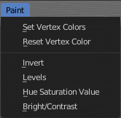

Set Vertex Colors
Sets the color of all selected vertices to the current active vertex color.

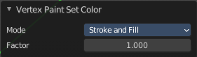
Last operator Vertex Paint Set Color

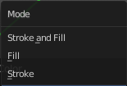
Mode
What vertex colors to affect.

Factor
How strong the color is set compared to the old color.

Reset Vertex Color
Resets all vertex color to white.

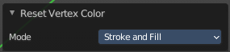
Last operator Reset Vertex Color

Mode
What vertex colors to affect.

Invert
Inverts the stroke colors.

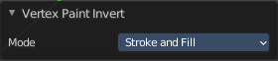
Last operator Vertex Paint Invert

Mode
What vertex colors to affect.

Levels
Adjust the levels of the vertex colors.

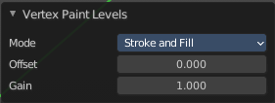
Last operator Vertex Paint Levels

Mode
What vertex colors to affect.

Offset
Value to add to the colors.

Gain
Value to multiply colors by.

Hue Saturation Value
Adjust the HSV colors of the vertex colors.

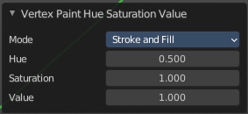
Last operator Vertex Paint Hue Saturation Value

Mode
What vertex colors to affect.

Hue
The hue value

Saturation
The saturation value.

Value
The value value.

Bright Contrast
Adjust the brightness and contrast of the vertex colors.

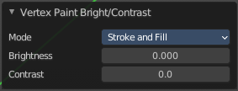
Last operator Vertex Paint Bright/Contrast

Mode
What vertex colors to affect.

Brightness
The brightness value

Contrast
The contrast value.

